eBBS Rules Engine User Guide

1 Introduction to Rule Engine 2
2 eGLEX Setup 2
2.1. Code Set Up 2
2.1.1. Process Group 2
2.1.2. Rule Group Code 4
2.1.3. Destine Code 7
2.1.4. Table List 8
2.2. Modules In Rule Engine 9
2.2.1. Process Group Setup 9
2.2.2. Rule Group Setup 11
2.2.2.1. Filtering Tab 13
2.2.2.2. Base field Tab 14
2.2.3. Rule Builder 16
3 PSTXBASE 21
3.1.1. Chartfields in PSTXBASE 21
3.1.1.1. Source Chartfields 21
3.1.1.2. Target Fields 23
3.1.1.3. Filp Entries 24
4 Procedure to make changes in the Rule Engine in the Front End 25
4.1.1. Procedure for creation of a new Rule Group 25
4.1.1.1. Rule Group Code to be created 25
4.1.1.2. Destine code for the relevant rule group to be created 25
4.1.1.3. Rule Group Setup to be created 25
4.1.1.4. Creation of Rules 26
4.1.1.5. Execution Sequence of the rule group to be updated 26
4.1.2. Modification to the existing rules 27
4.1.3. Deletion to the existing rules 27

Introduction to Rule Engine

Ebbs which is currently the GL of countries, contains data from all TP systems. On moving over to PSGL, the data held in eBBS are to be translated to PSGL chartfields and this is done in the eGLEX staging area using Rule Engine. It contains a set of various rules to arrive at the PSGL chartfields from eBBS chartfields.

EGLEX is the staging area, between ebbs (TP System) and PSGL (GL of the Bank). Data is extracted from ebbs, which is translated in PSGL chartfields using Rule Engine and is transferred to PSGL via secured FTP.

eGLEX Setup

EGLEX set up contains the following modules :

- Codes Set up

- Rule Engine

- Admin Task

- System Setup

- EGLEX Utility

From the PSGL translation point of view, the document covers the following :

- Codes Set Up

- Rule Engine

Code Set Up

This module covers the following:

- Process Group

- Rule Group

- Destine Code

- Table List

Process Group

In the Process Group we define the downstream interfaces from eBBS. At present there is only one Process group defined in eGLEX called PSGL. This is similar to “rlprsetup” sheet of the Rule Engine spreadsheet.

On traversing through eGLEX > Codes Setup > Process Group path following screen appears.

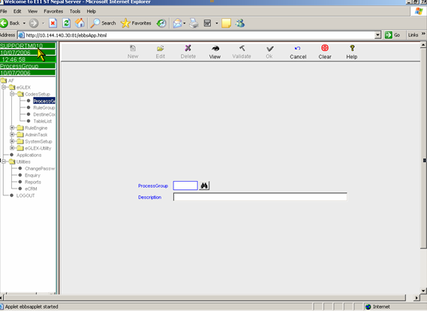

Click on Find button for Process Group which leads to the below screen.

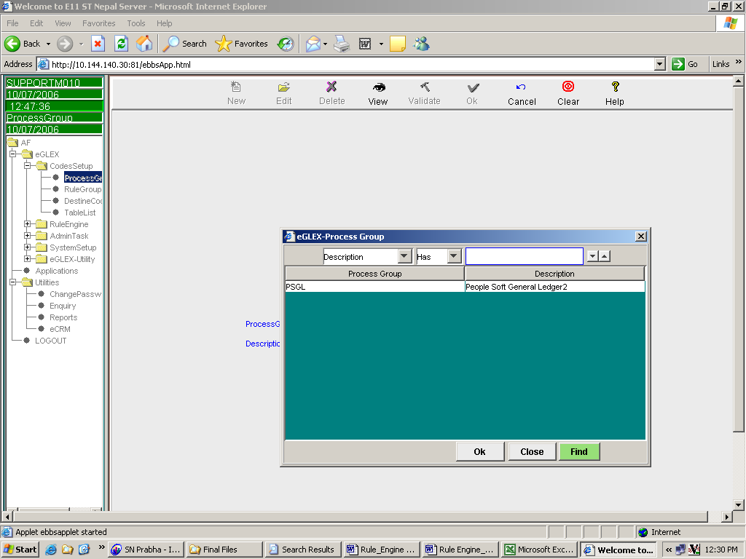

This is normally a onetime setup. This is similar to “rlprsetup” sheet of Rule Engine Spreadsheet. The Process Group so set should be authorized, using the authorizer ID.

Rule Group Code

Rule Group Code is the broad categorization of the rules to be set up. Unless we specify the rule group code, rules to the said rule group cannot be amended or added. This is similar to “rlgrp” sheet of the Rule Engine spreadsheet. On setting up the rule group code, there is no requirement to authorize the same and the user can proceed to the next step.

On traversing through eGLEX > Codes Setup > Rule Group path following screen appears. Click on Find button for Rule Group which leads to the next screen.

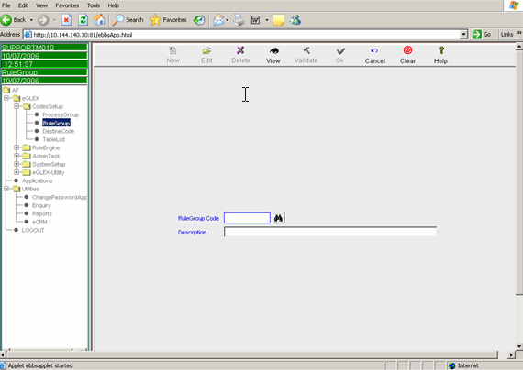

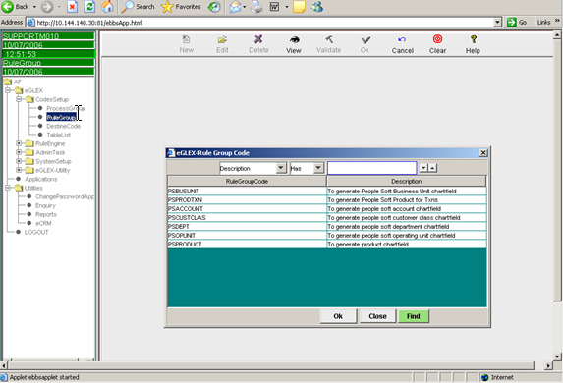

If a new rule group code is to be created, the user should go to the rule group code menu and select “New” Option and specify the Rule Group Code to be created together with the description. After setting the New Rule Group Code, the same needs to validated by using Validate option, to enable the Rule Group to be made available.

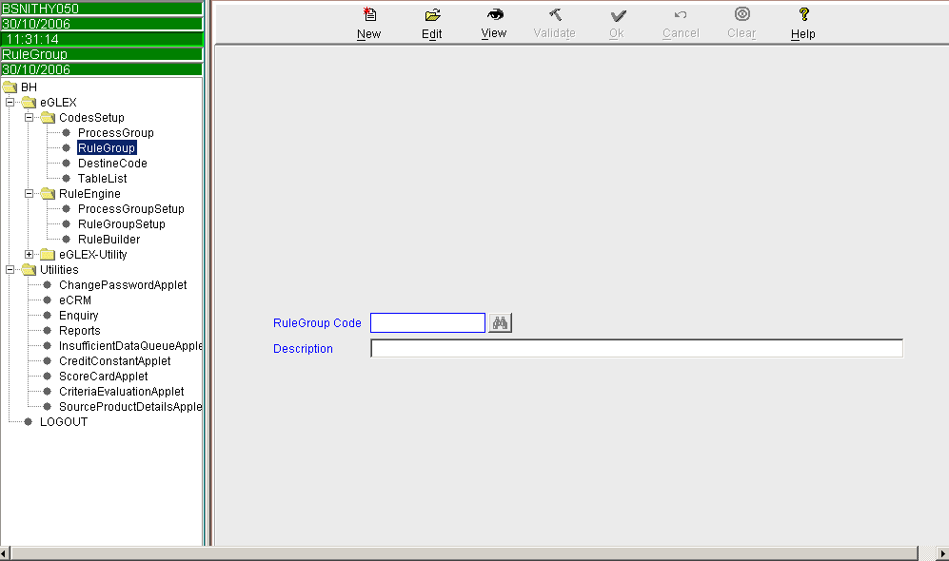

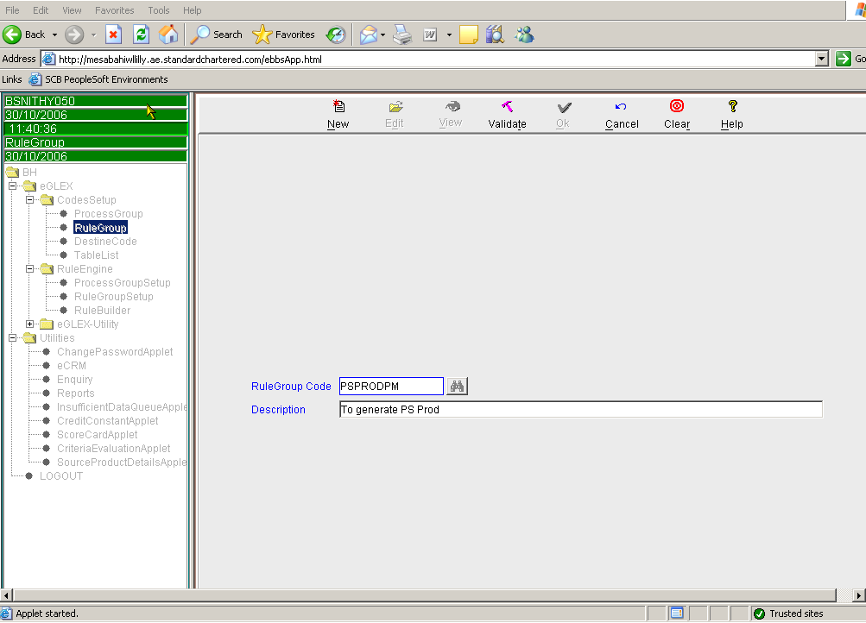

To view the existing rule group code, View option is to be used.

Destine Code

Destine codes are the target PSGL codes. This module maintains the set of PSGL target codes for each rule group. Unless the target codes are defined in this module, though they are available in the rule, there will be still a translation error. When we try to upload the rules via front end, unless the target values are specified the system will not allow to proceed on updating the rules. This is same as “rlpsgl” sheet of Rule Engine spreadsheet.

Any amendment to the Destine Code does not call for authorization.

The path is eGLEX > Codes Setup > Rule Group path following screen appears. Click on Find button for Rule Group Code which leads to the next screen

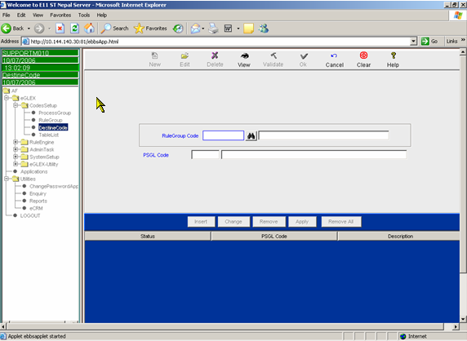

If the target value is to be added to the existing rule group code, then Use Edit Option and specify the desired rule group code, which would enable the edit options tab viz., Insert / Change / Remove.

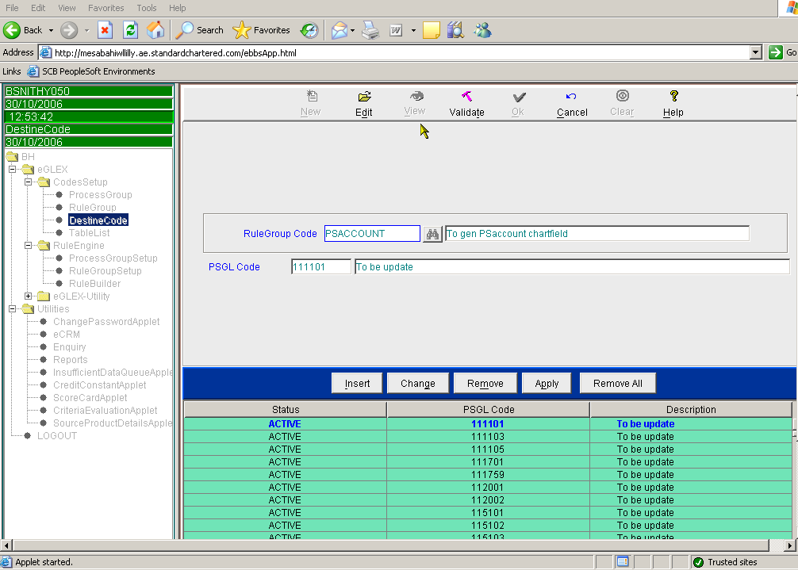

When Insert option is selected, specify the target value to be added together with the description. And when Apply Option is selected the destine code will be displayed in the screen with the status as NEW and when Validate Option is applied the status becomes ACTIVE. Only if the Status is ACTIVE the destine code will be made available for use.

Eg : If the target value for PSACCOUNT is to be added as 111101. Specify in Rule Group Code as PSACCOUNT or click on the search icon to find the rule group code and the PSGL code to be specified is 111101

When the destine code is not required, then place the cursor on the target value to be deleted and then select Remove option and the status will be displayed as DELETED and when Validate Option is applied the destine code will be removed permanently.

Table List

In the module Table List only one Table group called PSTXBASE is defined. The tables available in this module are hidden in the back end. This is similar to “rltables” sheet of the Rule Engine spreadsheet.

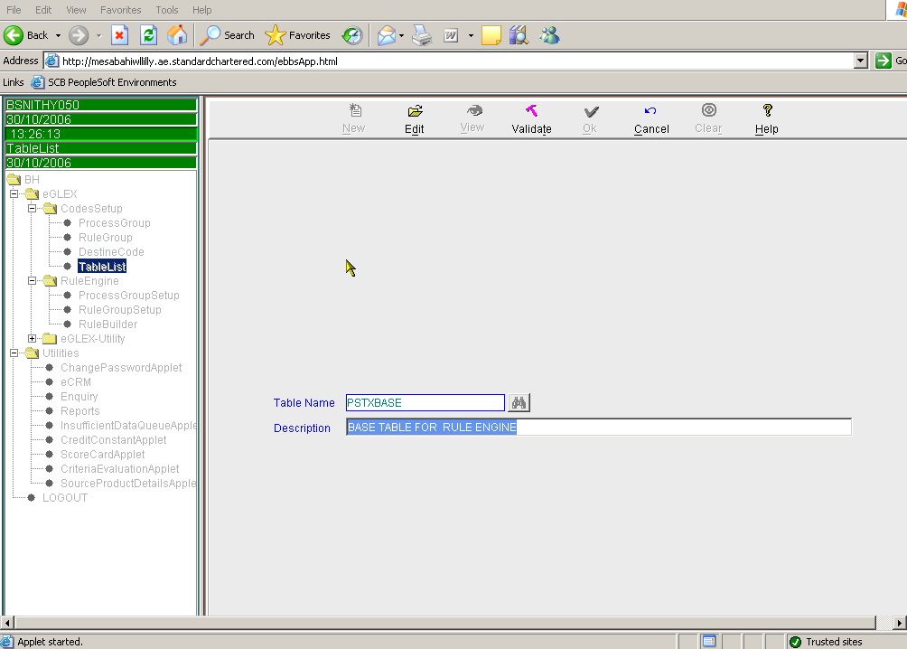

Modules In Rule Engine

As described in earlier paragraphs, Rule Engine holds various rules which when executed will provide the PSGL chartfields. There are various steps that are to be set up in order to execute the same.

Various modules that are to be set in the rule engine are:

- Process Group Set

- Rule Group Set

- Rule Builder

Process Group Setup

This module manages the sequence in which each rule group will be executed. The sequencing is of utmost importance especially in situation where one Rule Group is dependent on any other Rule Group. This is similar to “rlprsetupdt” sheet of Rule Engine spreadsheet. Any amendment to the setup does not call for authorization.

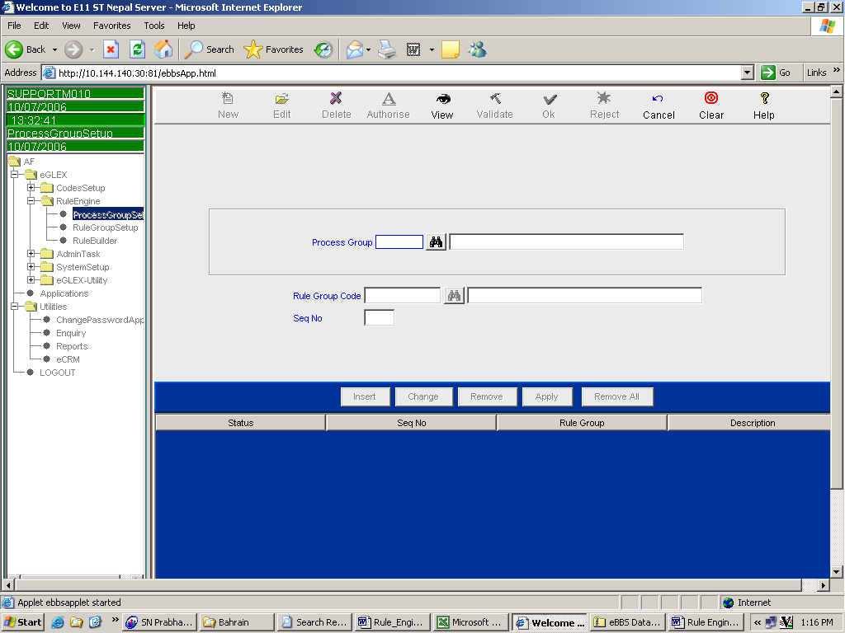

If any change in the Sequence has to be made then, edit option is to be selected and the necessary changes are to be executed.

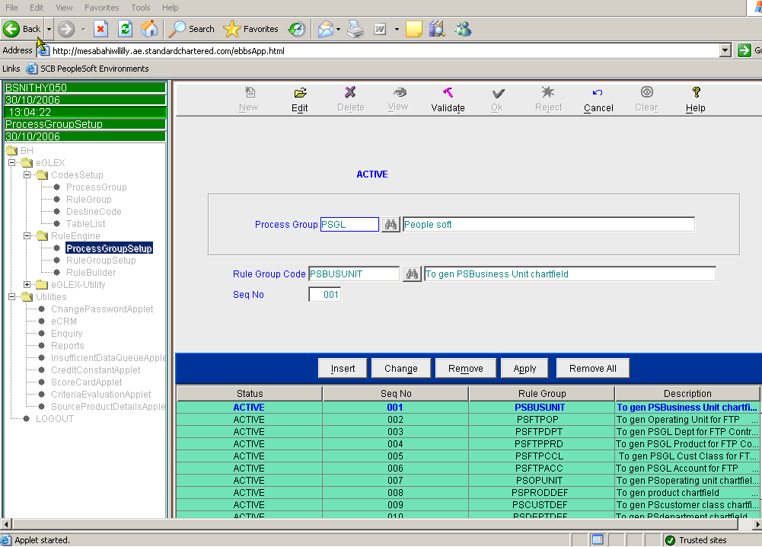

If the change in sequence is to be made to the existing rule group codes, then change option is to be used to amend the sequence numbers. When changing the sequence number, ensure the sequence is not in existence already, else amend the sequence of the other related rule group codes and proceed for further amendments. The status would be NEW, and on validation will become ACTIVE.

Eg., If in the above screenshot, PSFTPDPT to get executed prior to PSFTPOP, then we cannot go directly interchange the Seq no. of PSFTPDPT to 002, because PSFTPOP is currently holding that sequence. Hence change the seq No of PSFTPDPT / PSFFTPOP to a new sequence number, say PSFTPOP to Seqno 20 and then change the Seq No of the PSFTPDPT to SeqNo 002 and change the seq no of PSFTPOP to Seq No. 3.

If the new rule group is to be added and the sequence number of that rule group to be added in between the existing rule groups, the above process will be followed. If the new rule group code is to be added as the last sequence, then the user needs to insert the same and assign the sequence number.

Rule Group Setup

Rule Group Setup defines the parameters from source system required for the rules to generate the PSGL chartfields. This sheet is similar to “rlsetup”, “rlparam” and “rlmast” sheets of the Rule Engine Spreadsheet.

If the parameters are to be defined for the new Rule Group then “New” Option is to be used. Specify in the Rule Group option, the new rule group code and in the Base Table option specify “PSTXBASE” and click enter, which would give the various target columns that are available to be defined. Default Code to be specified is the code that would be generated when the rules cannot find the match. This would be XXXXXX for various chartfields like for PSPRODUCT will be XXX, PSACCOUNT will be XXXXXX. This is similar to “rlsetup” sheet of the Rule Engine spreadsheet.

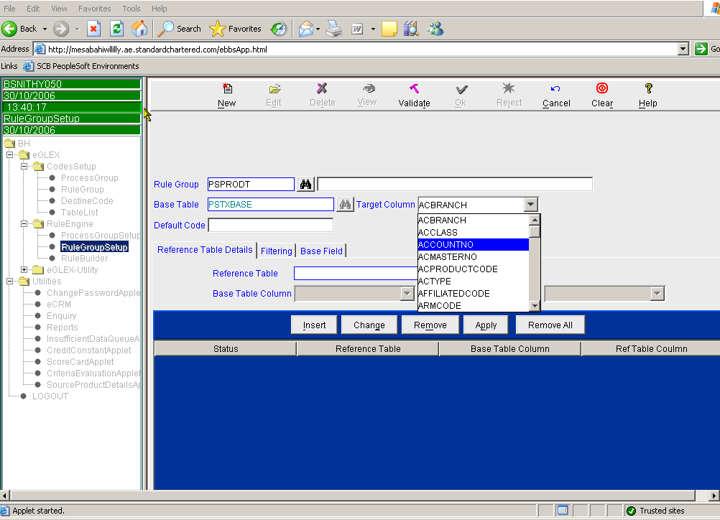

- Rule Group : Specify the rule group code to which we need to set the rule

- Base Table : The table by default is the PSTXBASE table where the output is generated

- Target Column : Represents the PSGL Chartfield

- Default Code : A default code is defined in circumstances where the rule engine does not generate any chartfield as there is no mapping or the mapping is invalid. A default code is represented as “XXX….”. The no of characters varies depending on the chartfields (Business Unit/Account/Product/Department/Operating Unit Unit/Customer Class).

Filtering Tab

These are nothing but the eBBS source fields which contains various parameters that are available in the PSTXBASE table and are represented as “Available Parameters”. All the criteria that are used along with the base value to arrive at the target value should be updated in the rlparameter.

Here we specify the criteria that are used for arriving at the target values. On selecting the various parameters that are to be used for the rules, the parameters will get displayed on the right side section. The new parameters added will be highlighted in the Blue Colour, the deleted parameters in Pink colour and those which are in Active Status will be in Orange colour. The status will become active only when authorized.

This is same as “rlparm” sheet of Rule Engine spreadsheet.

The screen shot of the same is appended below.
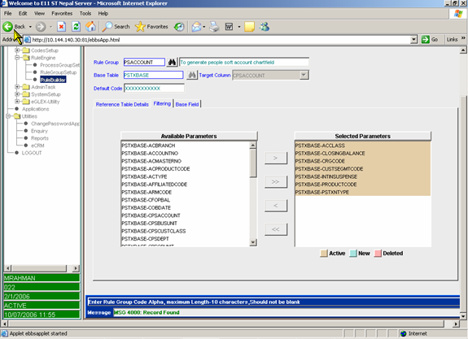

Base field Tab

This specifies whether the parameter selected in the filtering tab is a base value or not. Only one of the parameter can be specified as the “Base Value” for a Rule Group Code.

This is similar to “rlparam” sheet of the Rule Engine Spreadsheet.

The parameter which should be the Base value should be enabled in the checkbox.

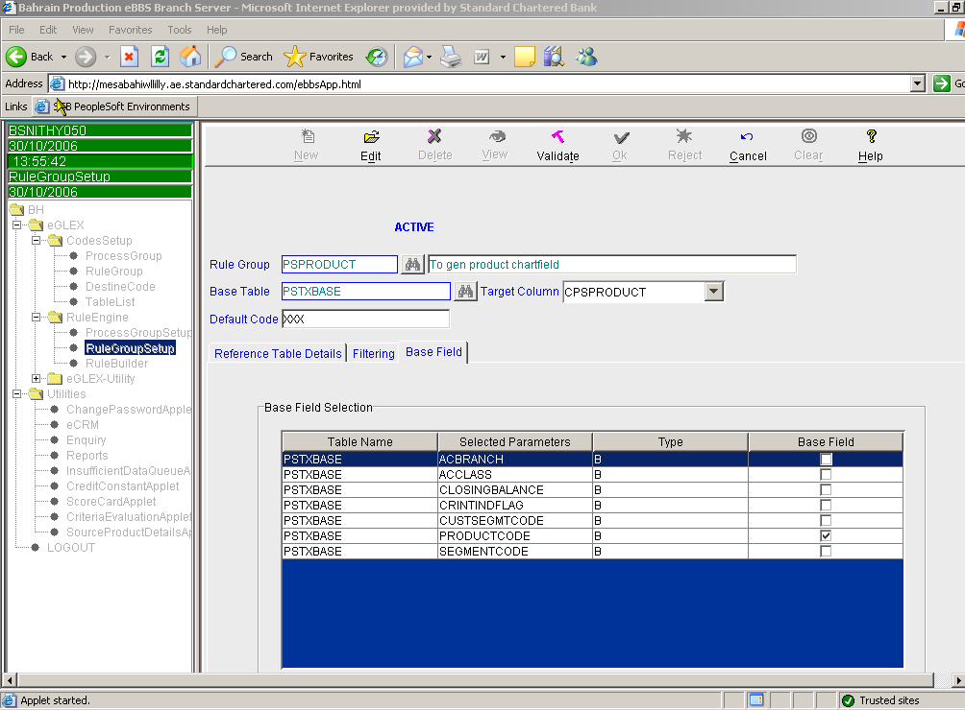

If the parameters are to be added or removed for the existing rule group then “Edit” Option is to be used and all the above specified process of updating will be applied as required.

Rule Builder

This defines the actual rule engine mapping is set to arrive at the target PSGL chartfields for each of the Base Value in the rule group code. This is similar to “rlexpdt” sheet of the Rule Engine spreadsheet.

There are two tabs in the rule builder (a) Base Value and (b) Define Rule tab

Base Value Tab is the place where we define the base field name and the value for which the rule is to build. The screen appears as shown below

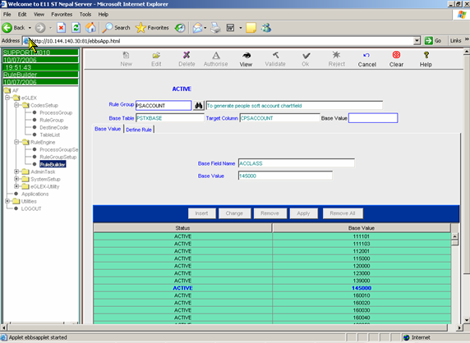

In the Define Rule tab, we will define the actual rule engine mapping. The screen appears as shown below.

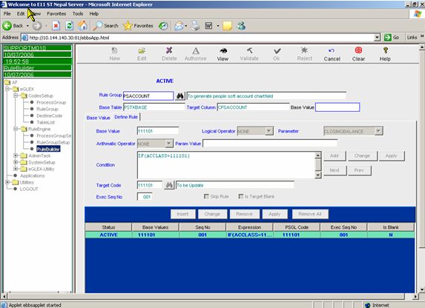

If the rule mapping is to be amended for the existing setup then specify in the rule group which needs to be amended and select from the Base value tab that needs to be changed and the necessary modifications will be made in the Define Rule Tab.

If the rule mapping is to be added for the existing rule group code, then use Edit Option and specify the rule group that needs to be amended. Select Insert option and specify the new Base value which should be added to the rule group code and then select apply. This would make the base value available. Click on the newly created base value from the bottom portion and specify the rules from the Define Rule Tab. In the Define Rule tab select Insert option and specify the rules. On specifying the rules and click Add and Apply Button (as available in the right side of the screen), specify the target code and the sequence number and select Apply Button in the bottom portion of the screen, which would display the rule and the STATUS would be NEW on validating the same. Conditions can be added by selecting from the available parameters which we enable at the time of filtering.

If the target code has not been defined, the system will not allow the user to define the rule. Also, if the sequences of the rules are overlapping then the system will throw up a warning message as to whether to override the existing sequence and when opted, the sequence number will undergo a change.

The rule needs to be authorized and on authorization, the status becomes active, which would then get executed.

Base Value: eBBS code for the relevant rule group.

Logical Operator: This is used if the target PSGL chartfield is to be arrived based on more than one parameter other than the base value. If more conditions are added then the Logical operators to be used will be AND.

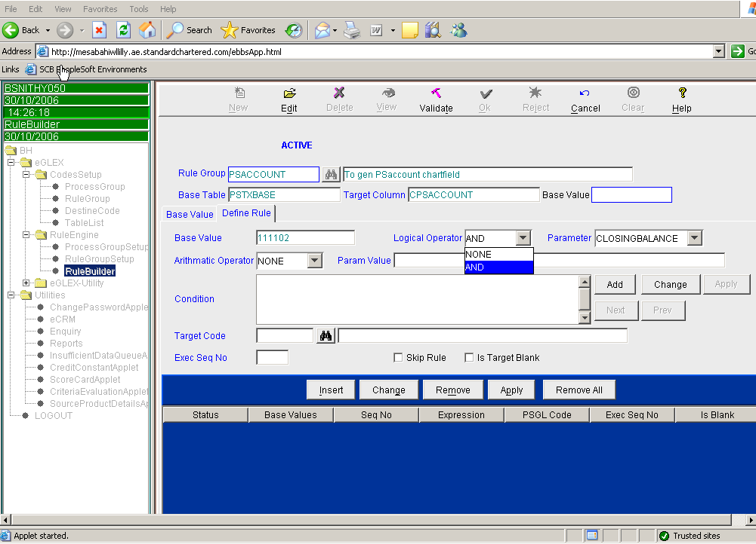

Parameter: Here we need to specify various parameters that are to be combined along with the base value. The Parmeter drop down box will show the list of various available parameters, which have been opted by us at the time of filtering.

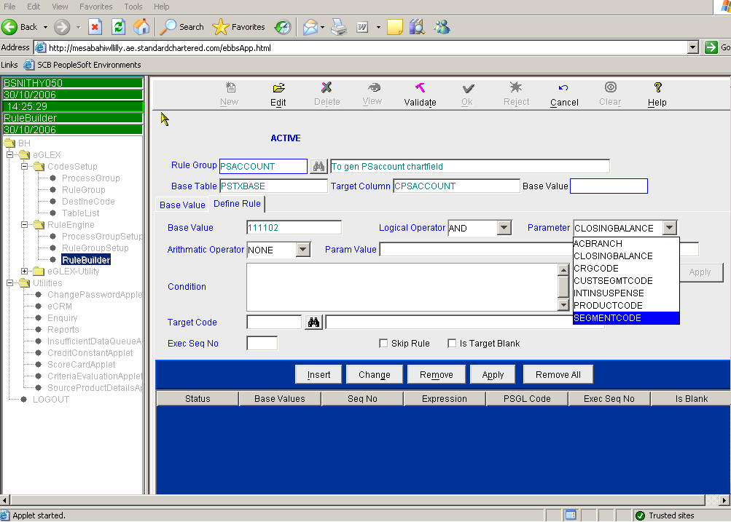

Arithmetic Operator: If the conditions are to be compared based on some criteria like <, >, >=, <=. != (not equal to) then from the drop down option specify the suitable operator.

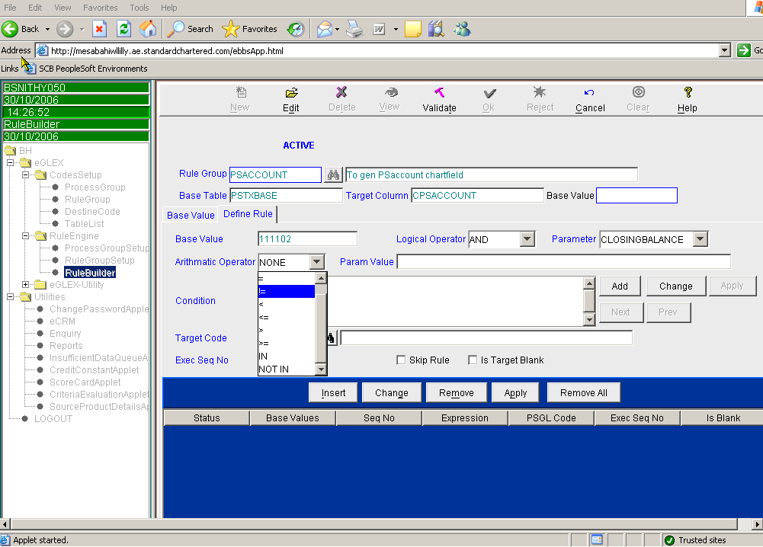

Param value : The value associated with the parameter condition is specified here.

Say if the condition to be specified is closing balance is greater than 0, parameter selected will be Closing Balance and the Arithmetical Operator selected will be > and the parameter value should be specified as “0”.

Condition : The rule mapping is specified here. The data gets updated here by selecting add and apply option available in the right side of the screen. If more conditions are to be added then the same needs to be added through add button

Target Code : Equivalent PSGL chartfield for the eBBS basevalue. Unless the target code is specified in the destine code, the rule cannot be saved.

Exec Seq No : The order of execution of rules. While building the rule mapping, all specific criterion should take priority to generic rules. It is a numeric field is a three digit code. While executing the rules the system looks for the base value and for that basevalue what are the various rules that are specified and the order of execution. The system goes by the logic of the execution sequence and the first rule that it encounters which is the best fit criteria for the base value will be executed and will not even look at the other criteria that are specified in the other sequence.

Eg : In PSACCOUNT rule mapping, for the base value ACCLASS = 111111, target PSGL Values are 111111 if the branch is 100 (irrespective of other chartfields), 111112 if the customer class is 10 and if none of the above two conditions are met then 111113
Exec Seq | Rule | Target Value
001 | IF ACCLASS=111111 AND ACBRANCH=010 | 111111
002 | IF ACCLASS=111111 AND CUSTCLASS=010 | 111112
003 | IF ACCLASS=111111 | 111113

If seq 1 is changed to seq 2 and seq 2 to seq 1, then if there is a balance in branch 010 with customer class 010, the target value will be 111112 instead of 111111.

Rule Skip : This box should be enabled if the rule is to be skipped

Target Blank : If the target value should be blank the box should be enabled. This is normally used for Cost, Tax and Contingent Contra accounts.

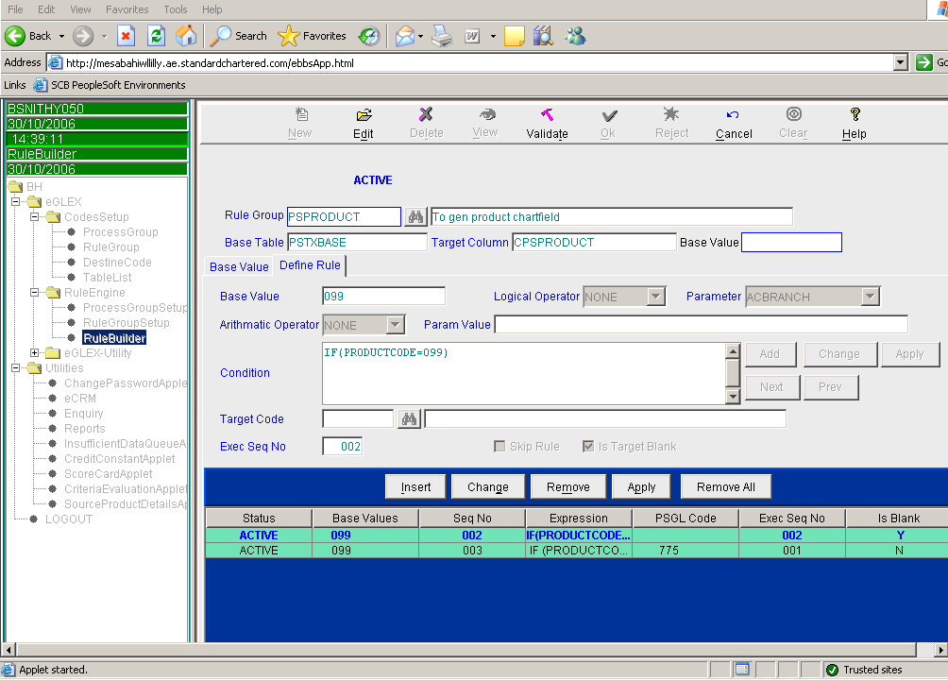

The rule needs to be authorized by the authorizer, only then the rule will get executed.

PSTXBASE

PSTXBASE maintains account level information from eBBS having the respective PSGL chartfields that have been mapped to the eBBS account number. In other words, eBBS chartfields and equivalent PSGL chartfields are maintained in this table for each account number (or deals). It also has some static data like ARM code, credit grading, Residency Status etc. Sample of PSTXBASE is attached herewith. For all transaction based accounts, the day’s transactions are captured in this table with only the transaction amount. For all balanced based, the opening balance, closing balance and transaction amount are captured.
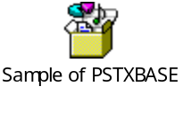

Chartfields in PSTXBASE

Source Chartfields

The table contains the following chartfields:

- Seq. No.

- TPS Code : Refers to the TP system to which the chartfields belong to. Primarily it will be either BBS for ebbs

- PSTXN Type : This denotes the type of the account whether it is Balance Type ‘B’ or transaction ‘T’ or Interest type ‘I’. At the time of conversion all accounts will be classified as Balance Type ‘B’, as we are converting all the balances at a point of time. Post cut over to PSGL, all P&L accounts will be classified as Transaction type and AIR/AIP accounts will be classified as Interest Type and all other Balance Sheet accounts are classified as Balance Type.

- CURRENCY CODE : Refers to the transaction currency.

- ACCOUNT Number : This is the eleven digit number assigned to every deal entered by the customer. Incase of balance based accounts, first two characters represent the product code, next seven characters represent the master number of the customer and the last two characters represent the branch code. Account number is always a unique number.

- Product Code : Represents ebbs product code.

- Master No. The number assigned to a group of Customers falling under the same ambit. Represents the mid seven characters of the account number. One master number will hold several account numbers rolling upto same ACCLASS or different ACCLASS.

- Opening Balance : Gives the opening balance of each account in the transaction currency. Positive balance represents credit balance and negative balance represents debit balance.

- Closing Balance : Gives the closing balance of each account in the transaction currency. Positive balance represents credit balance and negative balance represents debit balance.

- Transaction Amount : Represents the movement between opening and closing balance in the transaction currency. This will be in absolute signage.

- Credit / Debit : Represents credit / debit balance of the closing balance.

- ACBRANCH : It is a three digit code which represents the branch codes of the country.

- SEGMENT CODE : This two digit code represent the customer segment of the transaction.

- CUSTSEGMT CODE : This represents the customer class of the transaction. In ebbs the customer segment code already holds the data equivalent to PSGL Customer class. The customer segment code is arrived by applying data patch for those segments code.

- DRINTINDFLAG / CRINTINDFLAG : Represent interest indicator flag. This is used as one of the criteria to arrive at whether it is an interest bearing / non interest bearing liability or interest earning / non interest earning asset.

- INTINSUSP : Indicates whether the asset is a non performing (Y) or performing (N) one. This is used as one of the criteria for account mapping and used for CB segment only.

- CRGCODE : Represents the credit grade of the asset. If the credit grade is 13 or 14, the asset is considered as a Non Performing asset. One of the criteria for account mapping and used for CR segment only.

- ARMCODE : Represents the relationship manager code.

- ISICCODE

- ACCLASS : : Groups of Customer ACCOUNTNO ‘s with some common features are assigned a ACCLASS Number(ACN). ACCLASS are assigned by Finance based on the Financial Reporting Requirement and plays a significant role while mapping PSGL Chatfields.

Target Fields

- CPS ACCOUNT: Represents PSGL account number. This is arrived at using the rule mapping for ACCLASS as base value.

- CPSPRODUCT : Represents PSGL product using the rule mapping for PRODUCTCODE as base value.

- CPS DEPT : Represents PSGL dept. Incase of e10 version of ebbs, there is a GL DEPTID already existing, hence it is arrived using one on one mapping. Whereas in non e10 version, the PSGL dept id is arrived at using a combination of ebbs Product code and ebbs customer segment code.

- CPS BUSUNIT : Denotes BU arrived using the rule mapping for ACBRANCH as base value.

- CPSOPUNIT : Denotes PSGL Operating unit arrived using the rule mapping for ACBRANCH as base value. Where there are two BU’s operating units can be shared by both BU’s instead of having two different OU’s for both BU’s.

- Eg. Bahrain has two BU’s viz., BU 140 (DBU) and BU 138 (OBU). If both in DBU and in OBU there is an operating unit called treasury branch. Instead of mapping Treasury Branch of OBU to 100 OU and mapping Treasury Branch of DBU to OU 110, both of them can be mapped to OU 100 and the same can be differentiated by BU.

- CPSCUSTCLASS : Represents the PSGL customer class, arrived using CUSTSEGMT code as base value.

- PPSBUSUNIT refers to the PSGL Business Unit and this field gets populated only if there is a Carry Forward Balance from the previous day

- PPSACCOUNT refers to the PSGL Account and this field gets populated only if there is a Carry Forward Balance from the previous day

- PPSPRODUCT refers to the PSGL Product and this field gets populated only if there is a Carry Forward Balance from the previous day

- PPSDEPT refers to the PSGL Department and this field gets populated only if there is a Carry Forward Balance from the previous day

- PPSOPUNIT refers to the PSGL Operating Unit and this field gets populated only if there is a Carry Forward Balance from the previous day

- PPSCUSTCLASS refers to the PSGL Customer Class and this field gets populated only if there is a Carry Forward Balance from the previous day

- ACMASTERNO represents the master number of the account

- COB Date represent the Commencement of Business Date.

* For all balanced based accs, the ACPRODUCTCODE and PRODUCTCODE will be the same. In case of transaction based accs, the PRODUCTCODE will represent the eBBS prod which it carries during transaction and ACPRODUCTCODE represents the prod under which that account has been opened

** For all balanced based accs, the ACMASTER and MASTERNO will be the same. In case of transaction based accs, the MASTERNO will represent the eBBS prod which it carries during transaction and ACMASTER represents the prod under which that account has been opened

3.1.1.3. Flip Entries

Balanced based accounts (basically customer balances, prov accs, cash, nostro and suspense accs)

For Balanced based accounts, the flip entries works as follows:

In PSTXBASE, there are fields with CPSACCOUNT, CPSPRODUCT etc and PPSACCOUNT, PPSPRODUCT etc. CPS represents the PSGL chartfields derived today based on the today’s eBBS values and eGlex rules. PPS represents previous day chartfields.

Whenever there is a difference between any of the chartfields between CPS and PPS for an eBBS account, then it generates Flip entries. The transactions for the day are passed in the new combination and the Flip entries are generated for the opening balance only.

For example, say 22205015057 had the following chartfield on Day1:
Account | Prod | Dept | Oper unit | Cust class | Currency | Amount
133701 | 120 | 1531 | 100 | 10 | INR | 420

On Day2, if we change the product to 165 and say there is a transaction for INR 50, then Flip entry will be generated only for INR 420 since the transactions for the day would already go with Prod 165 combination. The flip entry generated has 2 components – R1 and R2. Flip entry is generated to make sure that PSGL also changes the entire balance of that account to the new chartfields. In this case, the entry will be as follows:

Type | Account | Prod | Dept | Oper unit | Cust class | Currency | Amount
R1 | 133701 | 165 | 1531 | 100 | 10 | INR | 420
R2 | 133701 | 120 | 1531 | 100 | 10 | INR | (420)

R1 basically is the reinstatement of opening balance with the right combination and R2 would reverse the old combination.

Procedure to make changes in the Rule Engine in the Front End

Procedure for creation of a new Rule Group

Following are the procedure to be followed when a new rule group code is to be created.

Rule Group Code to be created

Go to eGLEX > Code Setup> Rule Group >

Select “New” Option and specify the Rule Group Code to be created together with the description.

After setting the New Rule Group Code, the same needs to validated by using Validate option, to enable the Rule Group to be made available.

Destine code for the relevant rule group to be created

Go to eGLEX > Code Setup> Destine Code

Select “New” Option and specify the Rule Group Code in which the target value is to be inserted. Click Insert button.

Specify the target value to be added in PSGL Code row together with the description and click Apply. This would show the status NEW

Click validate option and the destine code is now available for use in the relevant group code. The status is now active.

Rule Group Setup to be created

Go to eGLEX >Rule Engine > Rule Group Setup

Specify the in the Rule Group rule group created, in base table specify PSTXBASE and type enter, which would provide in the target column the list of target values that are available.

Select from the dropdown list of values of the target column the CPS target member to be populated

In the filtering tab, double click from the available parameters, those parameters that are to be populated.

Selected parameters will now be available in the right hand side as available parameters.

Go to the Basefield tab and specify the field which would be the base value for the rule group code. There can only be one base value for each rule group code.

Click Validate and then Ok options.

The authorizer has to authorize the rule group code setup. After the authorizer has logged on, traverse through eGLEX > Rule Engine > Rule group set up. Specify the rule group name to be authorized and then click Authorise and then click Ok.

The rule group set is now authorized and is now available for the rule creation

Creation of Rules

Go to eGLEX > Rule Engine > Rule Builder

Specify the rule group and press enter

Click Insert and type the Base value for which the rule to be created and click Apply.

Click on the basevalue so created and go to define rule tab and click insert

After specifying the various parameters and click Add button and then Apply Button seen on the right side.

In the target value specify the target PSGL value.

In the execution sequence specify the execution sequence of the rule and then click Apply button seen on the bottom portion.

Once all the rules relating to the basevalue is created then click validate and the Ok.

After all the rule engine changes relating to the rules are made, the same needs to be authorized.

The authorizer has to authorize the rule builder setup. After the authorizer has logged on, traverse through eGLEX > Rule Engine > Rule Builder. Specify the rule group name to be authorized and then click Authorise and then click Ok.

Execution Sequence of the rule group to be updated

Go to eGLEX > Rule Engine > Process Group set up.

Specify in the Process Group as PSGL and click enter

Specify in the rule group the rule group name and click enter, which would provide the list of rules available in the database together with its sequence of execution.

Click insert and specify the rule group to be inserted together with its execution sequence number, after necessary changes to the existing rule group codes sequence, if any.

Modification to the existing rules

Go to eGLEX > Rule Engine > Rule Builder and specify the rule group name to be modified

Select the desired row and click the “Change” button directly above the child bar,

Then click the “Change” button directly to the right of the condition box.

You must hit the “Apply” button directly to the right of the condition box after you modify each part of the condition, to navigate from one section of the condition to another click on the “Next” button.

When you are satisfied with the amended condition you will have to click on the “Apply” button directly above the child bar.

Then click on “Validate” and then on “OK” icon on the Tool Bar on top. A rule becomes effective only if it is duly authorised using the Authorisers ID

Deletion to the existing rules

Go to eGLEX > Rule Engine > Rule Builder and specify the rule group name to be deleted.

Select the desired row and click the “Remove” button directly above the child bar and then press “Apply” button

Then click on “Validate” and then on “OK” icon on the Tool Bar on top. A rule becomes effective only if it is duly authorised using the Authoriser’s ID

